Our trainings can change your life! There is no going back once you understand the amazing power of listening. We provide a good amount of information and "ah-ha!" moments in our fun, relatable, and - if you like - highly tailored programs.
Trainings, Talks and Edutainment
(these programs can range from 1hour to 8 hours)

- Conflict Resolution Skills - Insurance Industry
- Extreme Listening
- Dealing with Difficult Customers
- Difficult Conversations: When There's Business in The Family and Family in the Business
- Sandwich Generation - Conflict with Your Children and Your Parents at the Same Time
- Marketing for Mediators

"Decker & Sullivan provided very effective training to our disability claims staff. The program was highly interactive and engaging. Every member of our team viewed the time as very well spent, and we will engage these folks again!"
Lisa Shelton-Doherty
Director
Sun Life Financial

Role Plays and Demonstrations:
- Prom Night (Role play demonstration of conflict between teenager and her mother)
- Holiday Travels (Two-part demonstration of the right way and the wrong way to handle the same sensitive call between adult son and his mother)
- 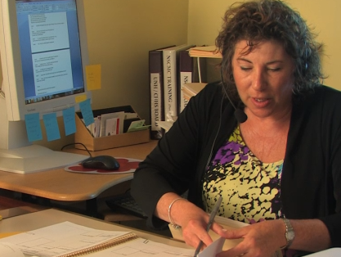Doctor's Office (Two-part demonstration of the right way and the wrong way for the medical receptionist to handle a caregiver's worried telephone call)
- Disability Claim Rep's Call (Audience role play used to practice skills learned in training. The claim has different outcomes based on the listening skills practiced).
- The Reilly Family (Demonstrates conflict styles)
- Miller Family (Sample mediation - family in crisis)
- Extreme Listening Exercise

